Deploying Quantized CNNs to Arduino UNO R4 WiFi
This document outlines the professional procedure for transitioning a "tiny_fruits" Convolutional Neural Network from a Python/Colab environment to the Arduino UNO R4 WiFi (Cortex-M4).

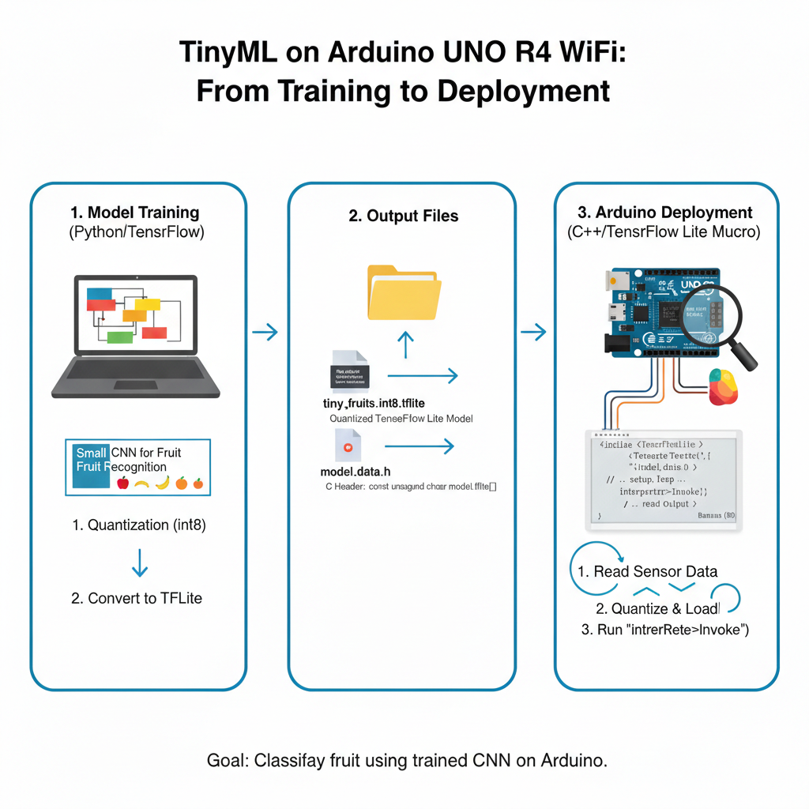

1. Prerequisites & Environment
- Hardware: Arduino UNO R4 WiFi.
- Software: Arduino IDE, Python (Google Colab), xxd utility (standard on Linux/macOS).
- Memory Constraints: * SRAM: 32 KB (Tensor Arena target: 8-12 KB).
  - Flash: 256 KB.

2. Phase 1: Model Export (Google Colab)
After training your model in TensorFlow, you must quantize it to int8 to ensure compatibility with the UNO R4's integer-only arithmetic optimizations.

Python Export Snippet
import tensorflow as tf

# 1. Convert to TFLite with Integer Quantization
converter = tf.lite.TFLiteConverter.from_keras_model(model)
converter.optimizations = [tf.lite.Optimize.DEFAULT]
converter.target_spec.supported_types = [tf.int8]

# Ensure input/output are also int8
converter.inference_input_type = tf.int8
converter.inference_output_type = tf.int8

tflite_model = converter.convert()

# 2. Save the model
with open('tiny_fruits_int8.tflite', 'wb') as f:
f.write(tflite_model)

Conversion to C++ Header
Run the following command in the Colab terminal to convert the binary file into a C-style array:
xxd -i tiny_fruits_int8.tflite > model_data.h
Edit model_data.h to ensure the array is marked as const unsigned char tiny_fruits_int8[] PROGMEM; to force it into Flash memory.

3. Phase 2: Arduino Library Modification
The standard Arduino_TensorFlowLite library contains Mbed-specific drivers that cause compilation errors on the Renesas RA4M1.
- Navigate to your Arduino libraries folder: Documents/Arduino/libraries/Arduino_TensorFlowLite.
- Open the src folder.
- Delete the folder named peripherals.
- Open TensorFlowLite.h in a text editor.
- Find and comment out the following line:
// #include "peripherals/peripherals.h"
- Save the file. The library is now a "Core-only" version compatible with the UNO R4.

4. Phase 3: Inference Implementation
The inference loop requires manual input quantization (mapping data to -128 to 127).

Key Constraints
- Tensor Arena: Allocated as a global uint8_t array.
- Quantization: Use the model's input->params.scale and input->params.zero_point.

5. Deployment Checklist
- [ ] Model is int8 quantized.
- [ ] peripherals folder deleted from library.
- [ ] Tensor Arena is $\leq 12$ KB.
- [ ] Input data is manually cast to int8 range.

